Oliver Amparo

4/24/2021

Security part 2

1. Cron job for monitoring users every hour.

This shows how every hour of every day etc this command is going to run appending whatever matches the pattern which is the pattern that will show any users. Also in the button you can see that the crontab didn't have any errors so it will run as expected.



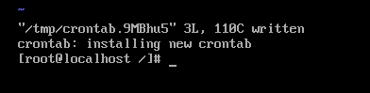

1. Daemon is basically all the background processes that are running. Disabling some of them is more secure because there is less room for error. This will also make your boot faster because the server wouldn't have to boot up everything at once only the things that are needed.

To enable a daemon you would want to run this command “systemctl enable debug-shell.service”.debug-shell.service being the thing that you want to enable. This will make it so that it is running in the background.



To disable a daemon you would need to run this command “systemctl disable debug-shell.service” .Disableing it makes it so that it does not run in the background. Therefore using less resources which makes everything faster and more efficient.



1. CentOS

To boot into emergency mode in centos you would want to power on your server and after you need to type e when it prompts you to choose the server. Then you would want to add systemd.unit= emergency.target. This is the way you are going to let the operating system know you are going to log in to emergency mode. Then you press ctrl-x. After that you will need to provide the root password.

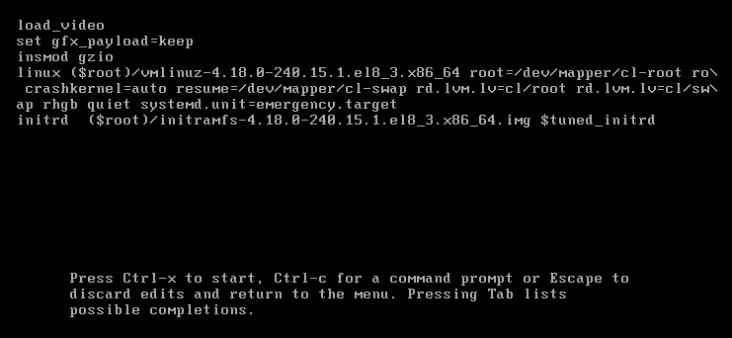

Ubuntu:

To boot into emergency mode in ubuntu you would have to power your server and type e. And instead of typing systemctl.unit= emergency.target. You would have to type systemd.unit=rescue.target next to where it says quit . Then do type do ctrl-x. After that something will pop up asking you for your root password. And you will be in emergency mode.

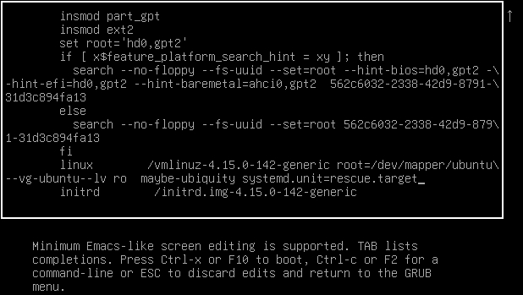

You would want to log into emergency mode if your server is messed up or if there is any type of error when you boot up. It does this by only booting the root files. Anything you want to change you can change it.

Include an explanation of how to set up a cron job, why they are used, and any sources you used for setting them up.﻿﻿?

To get up a cron job you would want to go to the terminal and run this command “crontab -e”. A cron job can make a command run at a schedule so that you don't need to run it everytime. You can run a command every certain amount of time. Basically you can run it every minute, every hour, every day, and every week. I used the youtube video below as a source for the cron job.

Sources:

<https://computingforgeeks.com/booting-centos-rhel-into-emergency-mode-recovery-mode/#:~:text=Booting%20CentOS%2FRHEL%207%268%20Linux,log%20in%20to%20emergency%20mode>.

<https://www.youtube.com/watch?v=4g1i0ylvx3A&t=720s>

<https://bash.cyberciti.biz/guide/Daemons#:~:text=A%20daemon%20>